stappenplan
Engels

Squat:
- Stand in a place where you have enough space around you.
- Then bend your knees until your buttocks are below knee height.
- Then stand up straight again.
- Repeat steps 2 and 3 15 times.
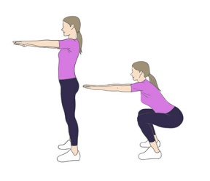
Push-up:
- Lie on your stomach, on the floor.
- Then put your hands down at shoulder height flat on the floor.
- Then push your body up until your arms are stretched.
- After this, you sink through your arms again until your nose almost touches the ground.
- Repeat steps 3 and 4 10 times.
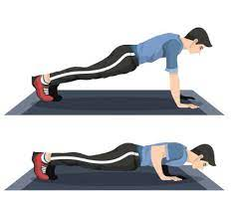
Dip:
- get 2 chairs.
- Place the chairs next to you so that they stand with their backs to you.
- Push yourself up so that you are off the ground with your feet and your arms are straight.
- Then you lower yourself down until your feet just don't touch the ground.
- Repeat steps 3 and 4 10 times.
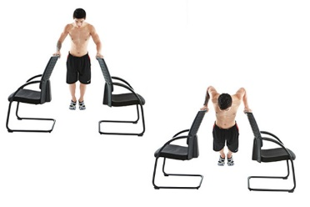

Plank:
- Lie on your stomach.
- Place your forearms on the floor.
- Make sure your elbows are under your shoulders.
- Now keep this up for 30 sec.
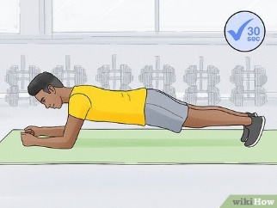
donkey kicks:
- Get on your hands and knees
- Stretch your left leg backwards until it is straight.
- Put your left foot back on the ground.
- Stretch your right leg back until it is straight.
- Put your right foot back on the ground.
- Now repeat these steps 10 times so that you have stretched your leg 20 times.
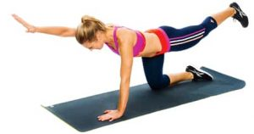
Mountain climber:
- Lie on your stomach.
- Just put your hands on the floor and stretch it.
- Make sure your hands are under your shoulders.
- Now pull your left knee towards your right elbow.
- And put your left foot back again
- Now pull your right knee towards your left elbow.
- And put your right foot back
- Now repeat these steps 10 times.
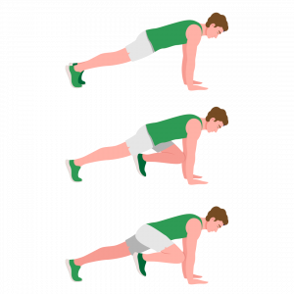

Burpee:
- Stand in a place where you have enough space around you.
- Jump in the air with your arms high.
- Now go through your knees and stand in push up position
- Now go through your arms and make sure that your nose does not touch the ground.
- Now stretch your arms again.
- And stand up again.
- And jump again.
- Now repeat 15 times
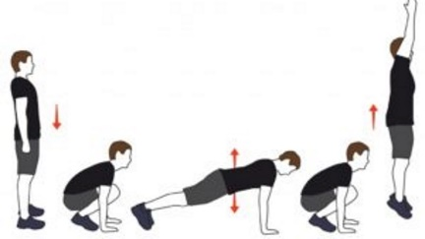
Lungs:
- Stand up.
- And put your right foot forward and make sure it is at a 90 degree angle.
- Make sure that your left leg is also at a 90 degree angle where the knee just beardly touch the ground.
- Now put your left foot forward and make sure that it is now at a 90 degree angle.
- Now you also have to stand your left leg with a 90 degree angle and the knee just beardly touch the ground.
- Now repeat this 10 times.
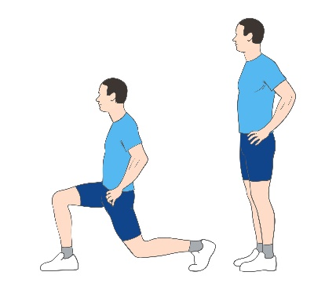
Wall sit:
- Stand against the wall.
- And make sure your legs are at a 90 degree angle.
- Your back should now be right against the wall.
- And make sure you keep this up for 30 seconds now.
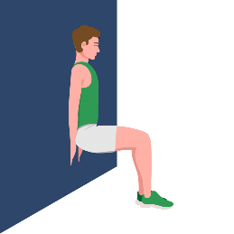
Crunch:
- Lie on your back.
- And put your feet straight on the ground and your legs a little bent.
- Put your hands under your head.
- And make sure your head goes up and keeps your back straight on the ground.
- And lower this back to the ground.
- Now repeat this 20 times.
